Balsamic Caramel Beef Cubes and Sticky Rice with Shiitake Mushrooms

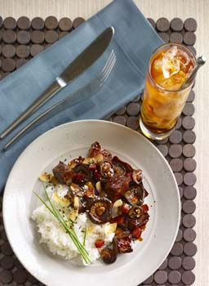
Balsamic Caramel Base
3 quarts vegetable, chicken or veal stock
3/4 cup balsamic vinegar
3/4 cup sweet soy sauce (kecap manis; see Note)
6 tablespoons sugar
1 tablespoon garlic, minced
1 tablespoon ginger, minced

Gomaishio
1/4 cup black sesame seeds
1/4 cup white sesame seeds
1½ teaspoons red chili flakes
- sheet nori
- tablespoon kosher salt

Olive oil, as needed
6 pounds beef tenderloin, cut into 1-inch cubes
1½ pounds shiitake mushroom caps, roasted
3 pounds beets, roasted, diced
3/4 cup unsalted butter, softened
8 cups medium-grain sticky rice, cooked
Shaved, unsweetened coconut, toasted, for garnish
Fresh chives, minced, for garnish

Directions
For Balsamic Caramel Base: Bring stock, vinegar, soy sauce, sugar, garlic and ginger to a boil in pot. Set aside. (Makes about 14 cups)

For Gomaishio: Toast nori in dry pan, then pulse it in a spice grinder or food processor until minced. Mix with sesame seeds, chili and salt. (Makes about 1½ cups)

For each serving, to order: Heat dash of oil in sauté pan. Sear 4 ounces of beef to brown, remove from pan. Add 1/2 cup Balsamic Caramel Base, 1 ounce of mushrooms and 2 ounces of beets. Swirl in 1 tablespoon butter, boil until it reaches sauce consistency. Add back the beef to warm through. Plate 1 cup sticky rice, top with beef and sauce mixture. Garnish with 1 teaspoon gomaishio, dash of toasted coconut and chives.

Note: If unable to find kecap manis, substitute 3/4 cup regular soy sauce, 1/4 cup brown sugar, 3 tablespoons molasses and 1 or 2 star anise pods.

