Churrasco a la Cubana with Mushroom Escabeche

Grilled skirt steak with a parsley, lemon and onion sauce; served with roasted garlic mashed potatoes, watercress, and a rosemary mushroom escabeche salad.

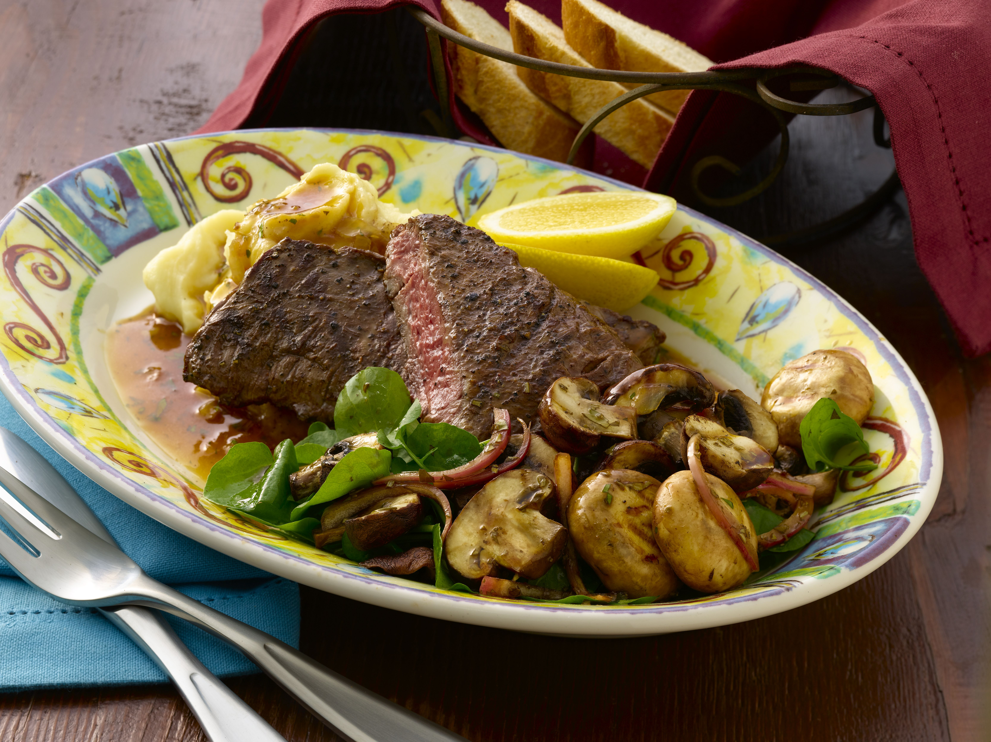
For the Parsley Lemon Onion Sauce:
Makes 24 two-ounce portions

1 quart lemon demi Sauce (recipe follows)
1 ½ pounds of onion sofrito (recipe follows)
6 ounces unsalted butter
¾ cup chopped Italian parsley
Salt and pepper

For the Lemon Demi Sauce:
Makes 1 quart

3 cups veal demi glace
8 ounces fresh lemon juice, strained through chinois
2 tablespoons cornstarch
¼ cup water
2 tablespoon salt

For the Onion Sofrito
Makes 1 ½ pounds

1 ½ pounds white onions, small dice
1 cup olive oil
4 teaspoons minced garlic
4 tsp teaspoons salt

For the Grilled Mushroom Escabeche:
Makes 24 one-ounce portions

6 pounds medium button mushrooms, stemmed
3 pounds crimini mushrooms, sliced laterally
18 ounces shiitake mushrooms, stemmed, wide julienne
6 ounces red onion, julienned
¼ cup minced garlic
9 ounces red wine vinegar
9 ounces balsamic vinegar
6 ounces lime juice
9 ounces orange juice
9 ounces olive oil
¾ cup granulated sugar
6 tablespoons salt
¾ cup chopped Italian parsley
2 tablespoons chopped fresh rosemary

For the Roasted Garlic Mashed Potatoes
Makes 24 eight-ounce portions

12 pounds Yukon gold potatoes, peeled and quartered
2 cups heavy cream, warm
12 ounces unsalted butter, diced
3 ounces roasted garlic, pureed

For Each Serving, to Order:

8 ounces skirt steak
8 ounces roasted garlic mashed potatoes
2 ounces parsley lemon onion sauce
1 ounce grilled mushroom escabeche
1 bunch watercress, small handful

Directions

For the Parsley Lemon Onion Sauce:
In a small saucepan, bring the lemon demi sauce to a simmer and reduce briefly. Add the onion sofrito. Remove from the heat and mount with butter. Season with salt and pepper and stir in the parsley.

For the Lemon Demi Sauce:
Combine the demi glace and lemon juice in a medium pot. Reduce briefly and slowly, skimming, as needed, to remove any film that may form on the surface. Mix together the cornstarch and water. Slowly add the salt and cornstarch mixture to the demi sauce, whisking, and cook until it thickens. Season to taste.

For the Onion Sofrito:
Combine all the ingredients in a sauce pan and cook on low heat until the onions are semi-soft and translucent, taking care not to burn or brown. Cool.

For the Grilled Mushroom Escabeche:
Toss each variety of mushrooms in a separate bowl, seasoning each with oil and salt. Spread the mushrooms on roasting racks and grill in batches. Transfer grilled mushrooms to one bowl. Mix together the onion, garlic, vinegars, juices, oil, sugar, herbs, and salt and pour over the warm mushrooms. Mix gently until the mushrooms are well coated. Marinate them for 24 to 36 hours before serving, for maximum flavor.

For the Roasted Garlic Mashed Potatoes:
Add potatoes to salted water in a large pot. Bring to a boil and then reduce to a simmer, cooking until potatoes are done. Strain and transfer potatoes to a stand mixer with a paddle attachment. Add heated heavy cream, butter and garlic and mix until smooth. Add salt to taste.

For Each Serving, to Order:
Grill steak to appropriate temperature and rest. Plate the mashed potatoes and arrange the steak on top of mashed potatoes. Sauce the steak with the Parsley Lemon Onion sauce. Arrange watercress and mushroom escabeche on plate.

