Portobello Fries served with Angus Filet

Yield: 4 servings

Ingredients Weights/Measures
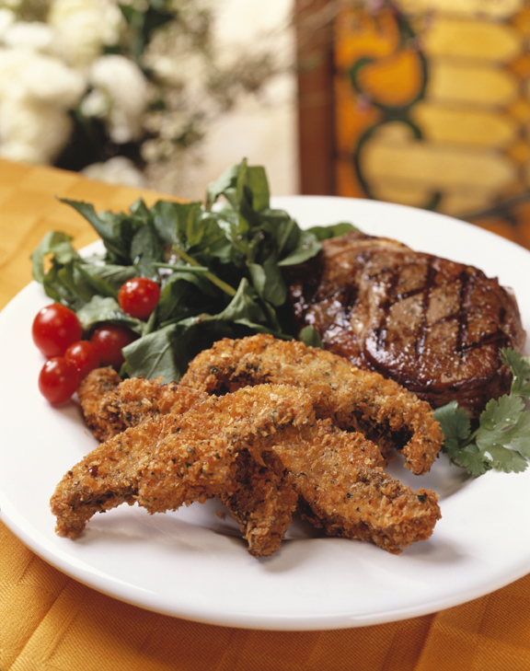
Portobello mushrooms 2
Angus “Filet Chops” 4
All purpose flour, sifted 1/4 cup
Egg wash 1/2 cup
Canola oil, for frying; heated to 350°F as needed
Savory breading (recipe below) 1/2 cup

Savory Breading
Panko Bread Crumbs 1 pound
Parmigiano-Reggiano cheese, 8 ounces
finely grated
Romano Cheese, finely grated 4 ounces
Ground Black Pepper 1 ounce
Crushed Red Pepper Flakes 1 ounce
Italian Parsley, finely chopped ¼ cup
Fresh Mint leaves, finely chopped ¼ cup
Lemon peels, finely grated ¼ cup
Orange peels, finely grated ¼ cup

Method
Clean and stem mushrooms; cut into 1/2-inch thick strips. Dredge strips in flour and shake off excess flour from mushrooms; place in egg wash followed by savory breading. Place breaded strips in hot oil for 2-3 minutes, until golden brown. Drain and serve at once with grilled Angus filets.

Savory Breading
In a bowl, thoroughly mix Panko bread crumbs, Parmigiano-Reggiano cheese, Romano cheese, ground black pepper, red pepper flakes, Italian parsley, fresh mint leaves, and lemon and orange peels. Refrigerate breading mix in a container with airtight lid.

