Portobello Meatloaf

Yield: 4 loaves; each serves 4 to 6

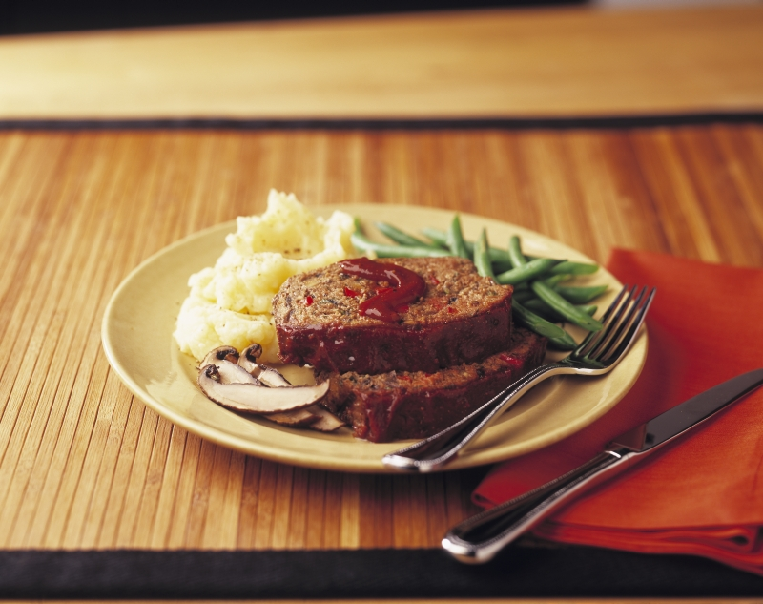
For the meatloaf
6 tablespoons unsalted butter
1 cup fresh bread crumbs
6 tablespoons canola oil
2 large red onions, thinly sliced
4 teaspoons kosher salt
1 2-inch piece gingerroot, peeled
and finely minced
8 Garlic cloves, finely minced
1 Jalapeño pepper (seeded and veined
for a milder flavor), finely minced
4 teaspoons ground coriander
2 teaspoons ground cumin
2 teaspoons cracked peppercorns
8 Portabella mushroom caps
(about 2 pounds), gills removed
and caps finely diced
1 teaspoon cayenne pepper
2 teaspoons garam masala
5 pounds ground beef (preferably 80% lean)
2½ pounds ground pork
2 Red bell peppers, seeded and finely chopped
1/2 cup finely chopped cilantro
6 Large eggs
1 cup ketchup
1 cup (4 ounces) grated Parmigiano-Reggiano cheese
1 teaspoon paprika

For the ketchup glaze
2 cups ketchup
2 teaspoons tamarind paste
4 teaspoons ground coriander
2 teaspoons ground cumin
2 teaspoons cracked peppercorns
1 teaspoon cayenne pepper

Melt the butter in a medium skillet over medium-high heat. Add the breadcrumbs and toast until browned, stirring often, for 3 to 5 minutes. Transfer to a large bowl and set aside to cool.

Place 1 cup of water next to your cooktop. Sautee the onions and salt with the oil in a large pot over medium-high heat, cooking the onions until they’re soft and just starting to brown, stirring often. Stir in the ginger and cook, stirring often to prevent the ginger from burning and splashing with water if it starts to brown to much, until it’s fragrant, about 30 seconds. Add the garlic and jalapeños and cook until the garlic is fragrant, splashing with water if necessary, for about 1 minute. Stir in the coriander, cumin, and cracked pepper and cook for 1 minute, stirring and scraping the bottom of the pot often and splashing it with water whenever the spices or onions begin to stick to the bottom of the pot.

Add the mushrooms and cook, stirring often, until they release their liquid and the liquid is evaporated, 6 to 8 minutes. Stir in the cayenne pepper and cook for 30 seconds. Stir in the garam masala, turn off the heat, and set the pot aside to cool.

Add the meat and the remaining ingredients to the bowl with the breadcrumbs, kneading it until all everything is completely incorporated. Add the cooled mushroom mixture and knead until combined. Divide the mixture evenly into four 8½ x 4½-inch loaf pans and bake for 1 hour (or cover the loaf pans with plastic wrap, place inside of resealable freezer bags, and freeze for up to 3 months; defrost overnight in your refrigerator before baking).

Whisk the glaze ingredients together. Remove the meatloaves from the oven and carefully drain off any pooled fat in the pans. Evenly divide the glaze over each meatloaf and continue to bake for an additional 30 minutes, or until the internal temperature of the loaves reads 165°F on a digital thermometer. Let the meatloaves cool for 15 minutes before serving. Run a knife around the pan’s edges, slice, and serve.

