Roasted Mushroom Hummus & Steak Bruschetta
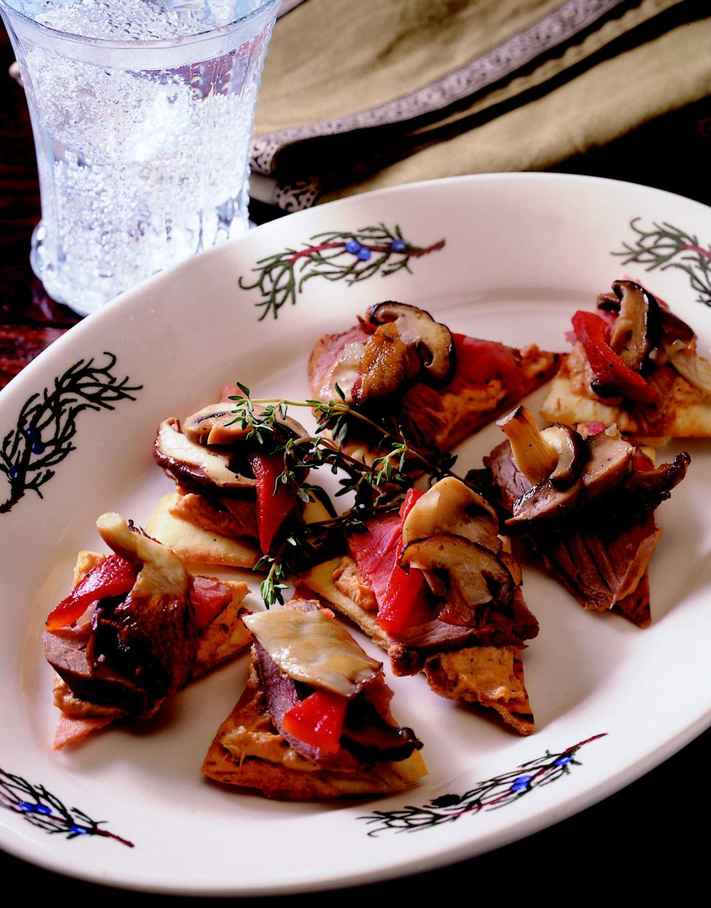

Roasted Mushrooms
Medium white mushrooms, 8 oz
sliced
Shiitake mushrooms, sliced 8 oz
Portabella mushrooms, 8 oz
stemmed and sliced
Oyster mushrooms, sliced 8 oz
Chopped yellow onion 4 oz
Chopped garlic 2 oz
Olive oil 2 oz
Kosher salt 1 tsp
Cracked black pepper ½ tsp

Hummus
Garbanzo beans 1 can (14 oz)
Tahini paste (sesame paste) ½ cup
Chopped garlic 1 Tbsp
Juice of one lemon 1
Olive oil ½ cup
Roasted Red Peppers ½ cup
Roasted Mushrooms Mixture 2 cups

Roasted Mushrooms
Toss all ingredients together. Place on a sheet pan, do not crowd product. Roast at 400˚F. until brown and tender, about 10 to 15 minutes, stirring once.

Hummus
In food processor, combine garbanzo beans, tahini paste, garlic, lemon juice, olive oil, roasted red peppers and 2 cups of the roasted mushroom mixture. Blend until smooth and creamy.

Appetizers
Pita Bread 4
Roasted tri-tip roast (medium rare), very thinly sliced 32 slices
Roasted red pepper slices 32
Fresh thyme sprigs 32

Cut each pita into 8 pieces, brush lightly with olive oil and toast until crisp like a chip.

To assemble
Layer pita chip with roasted mushroom hummus, slice of tri-tip, a dollop of remaining roasted mushroom mix, a slice of roasted red pepper and sprig of fresh thyme.

