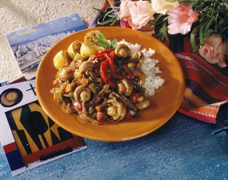

Spicy Cuban Flank Steak with Mushrooms

A myriad of flavors come together in this taste of Havana. After sampling this dish, one will realize Cuba should be known as much for its cuisine as its cigars.

Yields: 24 servings

Ingredients Weights Measures

Steak
Flank steak; cut in 3-inch squares 7½ pounds
Onions, chopped 2¼ pounds 1½ quarts
Bay leaves 6
Coarse salt 3 tablespoons
Fresh ground black pepper 1 teaspoon

- Put steak and next 4 ingredients in large pot; add water to cover and simmer, covered, about 1½ hours until tender. Set aside to cool.
- Remove and coarsely shred meat. Set aside. Strain and reserve liquid. Discard onions.

Sauce
Annato oil; divided* 1½ cups
Onions; finely chopped 3 pounds 1½ quarts
Sweet green peppers; cut in 1-inch squares 2½ pounds 1¾ quarts
Carrots; coarsely chopped 1 pound 3 cups
Garlic, finely chopped 1 ounce 6 cloves
Jalapeno pepper; finely chopped ½ tablespoon
Tomatoes; peeled, seeded and 8 pounds 1½ quarts
cut into 1-inch cubes
Coarse salt 2 tablespoons
Ground cinnamon 2 teaspoons
Ground cloves 2 teaspoons
Fresh ground black pepper 1 teaspoon
Beef stock or water as needed
Fresh White or Crimini mushrooms 4½ pounds, button
Capers; rinsed and drained ⅔ cup
Roasted sweet red pepper or pimiento strips; for garnish as needed

- To make sauce, heat 1 cup oil in pan; sauté onions and next 4 ingredients until soft, about 5 minutes.
- Stir in tomatoes and seasonings. Cook over high heat until mixture thickens.
- Stir in shredded meat and reserved cooking liquid, adding beef stock or water to make 1½ quarts. Heat through. Reserve
- Before serving, heat remaining ½ cup oil and sauté mushrooms until browned. Stir into sauce with capers. Cover and reheat. Keep hot.

Per order:
Serve 1⅓ cups hot meat and mushroom mixture garnished with red pepper strips.

*A vegetable oil colored with annato often used in Cuban cooking. Plain vegetable oil can be substituted.

