STEAK & MUSHROOM LOVER’S PIZZA

Yield: One 12-inch pizza

Ingredients Weights/Measures
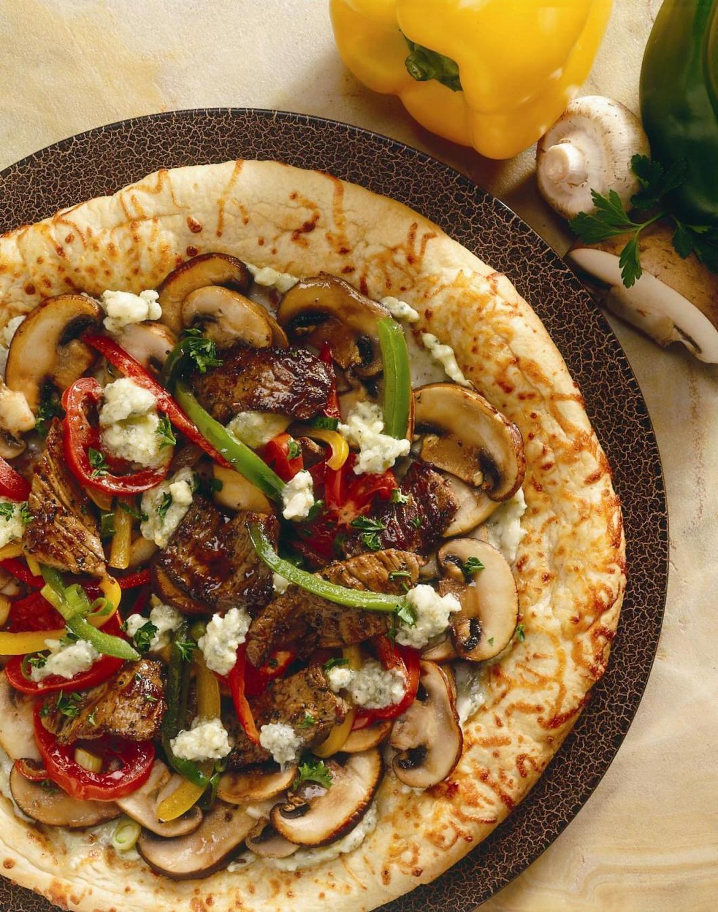
Creamy Roquefort cheese, 3 ounces
at room temperature
Unsalted butter, 1 ounces
at room temperature
Garlic, chopped finely 1 clove

Sirloin steak, sliced 1/8” x 2” 6 ounces
Salt as needed
Freshly ground black pepper as needed
Madeira wine 3 tablespoons
Canola oil 2 tablespoons
Julienned red, gold, and pepper 1 ounce each
Green onions, sliced thinly 1 ounce
Crimini Mushrooms, julienned 3 ounces
White mushrooms, 3 ounces
sliced ¼-inch thick
Unbaked 12-inch 1
pizza dough shell
Roma tomato, sliced 4 ounces
Chopped parsley 1 tablespoon

Method:
Beat together cheese, butter and garlic until smooth; reserve. Lightly season beef with salt and pepper; toss with wine and ½ tablespoon oil; reserve. Toss peppers and onion with ½ tablespoon oil; reserve. Toss mushrooms with 1 tablespoon oil; reserve.

Spread half the reserved cheese mixture over pizza shell; distribute reserved beef over cheese. Scatter reserved mushrooms over beef. Distribute tomato over mushrooms. Scatter peppers and onion over tomato. Dot with remaining cheese mixture.

Bake at 500°F until pizza is hot and bubbly, about 12 minutes. Remove from oven; sprinkle with parsley.

