Tuscan Steakhouse Prime Rib with Grilled Mushroom Salad

Yield: 1 serving

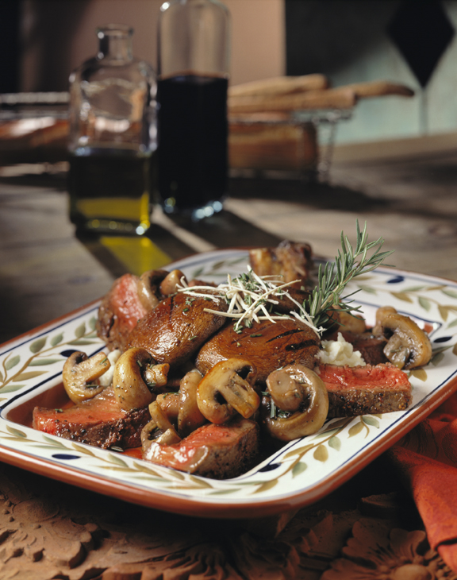
Ingredients Weights / Measures

Cowboy cut prime rib, 24 oz.
bone attached

Mushroom Salad
Portabella mushroom caps 3
White mushrooms 6
Extra virgin olive oil 2 oz.
Fresh rosemary sprig, chopped
Aged red wine vinegar 3/4 oz.
Water 1/2 oz.
Salt and cracked pepper to taste

Mashed potatoes 1 cup
Fresh horseradish, grated 3/4 oz.
Fresh rosemary sprig, for garnish 1

Method

- Grill steak until desired temperature. Keep warm.

- Meanwhile, for mushroom salad, grill mushrooms over medium high heat until soft. Place in bowl. Add olive oil, chopped rosemary, vinegar and water; season with salt and pepper. Reserve.

- To plate, place mashed potatoes in center of serving plate; top with grated horseradish. Remove beef from bone and slice. Arrange around potatoes. Garnish with bone and rosemary sprig.

- Top beef with mushroom salad, placing portabellas in middle and whites scattered around plate.

