Chicken Toscana

Yield: 24 servings

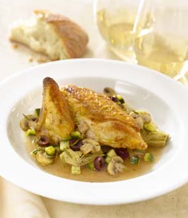
6 3-pound chickens, quartered
Flour, for dredging
Salt and pepper, as needed
Olive oil, as needed
Rosemary sprigs, as needed
12 small zucchinis, diced
1½ pounds white button mushrooms, sliced
2¼ pounds drained cured artichoke hearts, sliced
1¼ pounds black olives, sliced
1½ quarts dry white wine
3/4 cup unsalted butter

Directions
Dredge each chicken quarter in flour, salt and pepper. Heat oil and rosemary sprig in sauté pan and brown each chicken quarter on both sides. Finish in a 325-degree oven until cooked through.

For each serving, to order: Reheat or finish a chicken quarter. Heat oil and small rosemary sprig in sauté pan and add 1/2 cup each zucchini, mushrooms, artichokes and 1/3 cup olives. Sauté briefly, add 1/2 cup wine to deglaze. Simmer briefly, add 1 tablespoon butter to finish sauce. Season to taste with salt and pepper.

Plate chicken quarter with vegetables and drizzle sauce around and over.

