Paris Pizza Topped with Portabellas, Boursin and Brie Cheese, Tomatoes and Grilled Chicken

Yield: Makes 12 pizzas

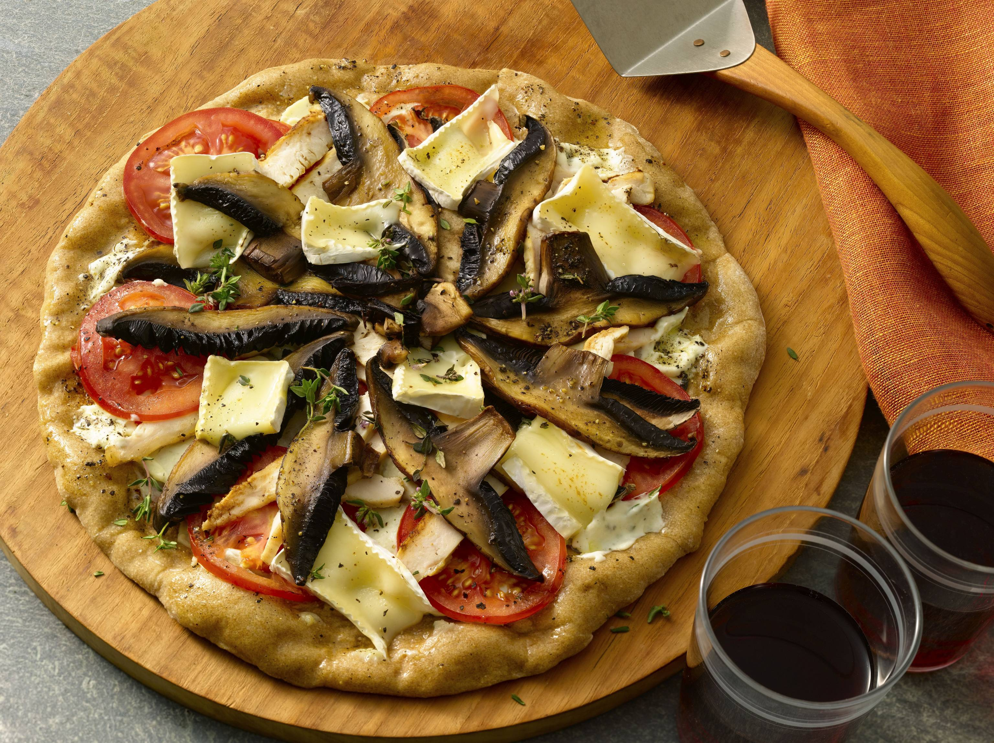
Ingredients
3 pounds, 6 ounces whole wheat pizza dough
2 pounds, 4 ounces Boursin cheese, softened
3 pounds, 12 ounces (12 med.) fresh tomato, thinly sliced
1 pound, 8 ounces thinly sliced raw portabella mushroom
3 pounds lightly grilled chicken scaloppine, thinly sliced
1 pound, 8 ounces Brie with the outer rind, sliced 1/8 inch thick

Directions
For each pizza, to order: Roll 4½ ounces of dough into a 10-inch circle. Spread 3 ounces Boursin cheese onto the pizza crust, and place a single layer of tomato slices (5 ounces) on top. Bake at 400 degrees Fahrenheit for 5 minutes, or until the tomato layer is warmed and the crust begins to crisp.

Fan 2 ounces portabellas onto the tomato layer evenly; sprinkle with salt and pepper. Bake for 2 to 3 minutes more.

Place 4 ounces chicken evenly over the mushrooms and scatter on 2 ounces Brie. Finish in the oven for another 2 to 3 minutes, being careful not to let the Brie get too hot, as it will tend to melt away. Cut the pizza into slices and serve immediately.

