Baked Mushroom Parmesan (foodservice portions)

Serves: 24
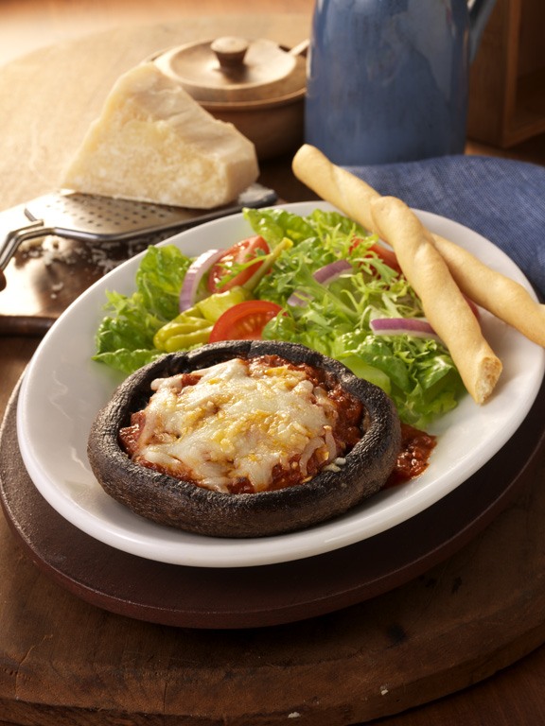
24 large Portabella mushrooms
Olive oil
6 cups tomato marinara sauce
24 fresh basil leaves, julienned
Crushed red peppers flakes
6 cups (1 1/2 pounds) shredded part-skim mozzarella cheese
1 1/2 cups (6 ounces) grated Parmesan cheese

For each serving, to order: Brush both sides of a mushroom cap with oil. Season with salt and pepper. Place the mushroom, gill side down, in a baking dish. Broil for 4 minutes, remove, and turn gill side up; broil 4 minutes more.

Spread 2 tablespoons marinara sauce in a small baking dish, then place the mushroom on top, gill side up. Sprinkle with 1 teaspoon basil, some red pepper flakes and 2 more tablespoons sauce. Top with 1/4 cup mozzarella cheese and 1 tablespoon Parmesan. Bake in a 400-degree oven until the cheese begins to brown.

