Filo Purses Stuffed with Mushrooms and Artichokes

Yield: 24 servings
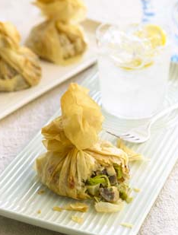
Olive oil
3 pounds white button mushrooms, quartered
1/4 cup garlic, minced
Salt and pepper, as needed
3 cups white wine
12 medium leeks, white party only, thinly sliced
6 pounds baby artichokes, trimmed, quartered
6 cups water
3/4 cup chopped fresh herbs: oregano, parsley, thyme, chives
12 ounces Asiago cheese, grated
6 ounces Parmesan cheese, grated
48 sheets frozen filo dough, thawed
Unsalted butter, melted, as needed

Directions
In large pan, heat oil and sauté mushrooms, 1 tablespoon garlic, salt and pepper to taste. Cook until mushrooms are golden and tender. Add 1 1/2 cups of wine and cook until pan is nearly dry. Remove from heat, set aside.

In another pan, heat oil and sauté leeks, remaining 3 tablespoons garlic, salt and pepper to taste. Cook until leeks are wilted, adding dash of water if necessary to keep from sticking to pan. Add artichokes, remaining 1 1/2 cups wine, and salt to taste. Cook until pan is nearly dry. Add water, simmer until artichokes are tender. Add mushrooms, cook together for 5 minutes. Drain any excess liquid, set aside to cool. Coarsely chop vegetables and combine with herbs and cheese. Season to taste with salt and pepper.

Working in batches, lay sheets of filo on a work surface and cut in half widthwise. Lay two half sheets horizontally, place two more sheets on top vertically to form a cross. Brush lightly with melted butter and spoon about 2/3 cup filling into center. Gather edges of dough up around filling and twist just above filling to seal, allowing top to fall naturally. Brush outside lightly with butter, including top edges. Place on parchment-lined sheet pan. Repeat until all filling is used. Wrap and refrigerate at this point or bake all of the purses.

To serve: Bake in 375°F oven until golden and crisp, about 35 minutes. Serve immediately.

