Grilled Mushroom Salad

Yield: 1 serving
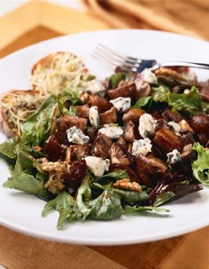

Ingredients Weights/Measures

Mushroom Mix:
White and Crimini mushrooms, halved; 6 ounces
Shiitake mushrooms, stems
removed and quartered;
Portobello mushrooms,
cut into 1-inch cubes.
Balsamic Vinegar, divided 2 ounces

Mesclun Mix: 3 ounces
Walnuts, toasted, & coarsely chopped 1½ tablespoons
Gorgonzola cheese, crumbled 2 tablespoons
Parmesan Croutons (recipe below) 3 halves

Method:

Per Order:
- Combine mushroom mix with ½ ounce dressing and toss to coat. Place on grill for approximately 2 minutes. Flip and finish grilling for about 1 more minute. Meanwhile reheat croutons on broiler.
- Combine mesclun mix with remaining 1½ ounce dressing, ⅔ of Gorgonzola and walnuts in mixing bowl. Toss to coat greens. Remove croutons from grill and place randomly in bottom of pasta bowl. Place greens on top of croutons. Place grilled mushrooms on top of greens in a random pile and top with remaining Gorgonzola.

Balsamic-Shallot Dressing:
Using a whip attachment, combine 52 fl. Oz. balsamic vinegar, 1½ cups granulated sugar, 12 oz. minced shallots, 4 oz. minced garlic, and ¾ cup coarse black pepper. With the mixer running on medium speed, slowly drizzle in 1 gallon olive oil until incorporated. Transfer to storage container and reserve. Makes 1¾ gallons.

Parmesan Croutons:
Cross slice day-old, dry ciabatta bread into 24½ inch wide slices. Arrange flat on pan and cover with 3 oz. grated Parmesan cheese. Sprinkle with 1½ tsp. dried oregano and ¾ tsp. fresh ground black pepper. Drizzle with 2 oz. olive oil. Broil until cheese melts and bread is browned around edges. Remove and cool. Reserve uncovered until served.

