GRILLED MUSHROOM SANDWICH RECIPE
Grilled Mushroom Sandwich is an easy to make vegetarian recipe. Learn how to make/prepare Grilled Mushroom Sandwich by following this easy recipe.
Difficulty: | Average | Rating: | 8.0
Recipe Type: | Veg.

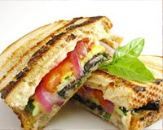
Ingredients:
• 4 Toasted buns
• 4 Portobello mushroom
• 2 Garlic flakes
• 4 Leaf lettuces
• 1/2 Cup vinegar
• Mozzarella cheese
• 1 tsp Pepper
• Salt to taste
How to make Grilled Mushroom Sandwich:
• | Chop the garlic flakes.
• | Mix olive oil, chopped garlic, vinegar,pepper and salt.
• | Marinate Mushrooms in this mixture for 2 hours.
• | Grill the marinated mushrooms till they turn soft.
• | Spread chesse slice on buns.
• | Top with a mushroom and lettuce leaf.
• | Top with another bun.
• | Grilled Mushroom Sandwich is ready.

