Grilled Philly Cheese Mushroom Sandwich (foodservice portions)

Serves: 24

24 large Portabella mushrooms, sliced
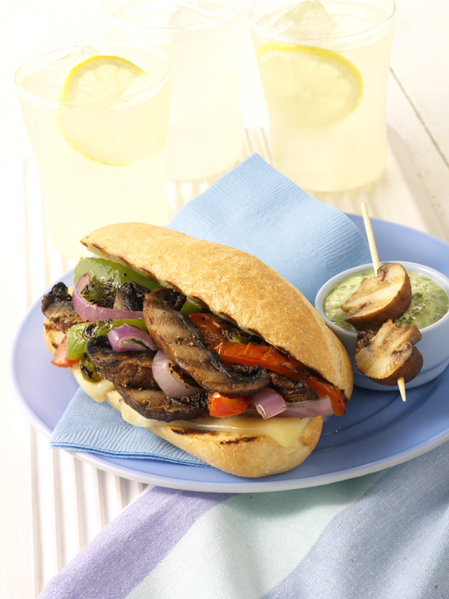
6 large red onions, sliced in rounds
12 bell peppers, quartered
Canola oil
2 tablespoons grilled steak seasoning
24 Italian rolls, toasted
48 slices provolone or American cheese or 1 1/2 pounds processed cheese spread

Brush both sides of mushrooms, onions, and peppers with oil and season with steak seasoning. Grill 5 minutes on each side. Thinly slice grilled vegetables and combine.

For each serving, to order: Lightly toast a bun on grill. Place 2 slices or 1 ounce cheese on each split roll, and top with about 1 1/2 cups mushroom mixture. Broil or bake until cheese is fully melted. Cut in half and serve immediately.

