Mushroom Bread Pudding

Yield: 20 servings

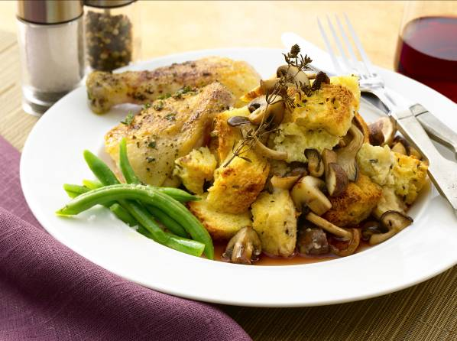
Ingredients
2 ¼ quarts heavy cream
18 large eggs
¾ cup (about 7 ounces) roasted garlic
2 lemons, zested
2 tablespoons chopped fresh thyme
2 teaspoons kosher salt
1 teaspoon ground black pepper
3 quarts 1½-inch cubes crustless bread (from about 1½ pounds bread)
3 cups (about 13½ ounces) mixed roasted mushrooms
1 ½ cups (about 5 ounces) grated Parmesan cheese

Directions
In a large bowl, beat together the cream, eggs, and garlic. Whisk in the zest, thyme, salt, and pepper. Fold in the bread, mushrooms, and cheese. Pour the mixture into a buttered 4-inch-deep half hotel pan.

Bake, covered, in a water bath at 325 degrees for 2 hours 15 minutes. Uncover the pudding and bake for 15 minutes more, until the top is browned and the pudding barely jiggles. Let it cool in the water bath. The pudding should be tall and deep so it has a pudding like texture and can be scooped, spooned or cut into blocks to plate.

