Mushroom “Chips” and Dip (foodservice portions)

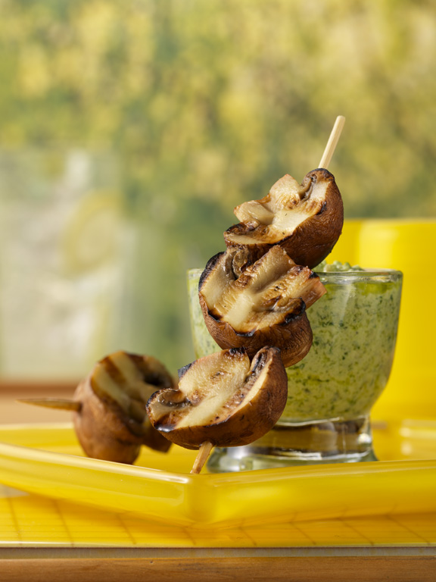
Serves: about 24 appetizers

3 cups pesto
3 cups light sour cream
72 large (about 3 pounds) white button or crimini mushrooms
Lemons, as needed

Mix pesto with sour cream, and set aside. Cut each mushroom in half. Season to taste with salt, pepper, and lemon juice.

For each serving, to order: Skewer 6 mushroom halves and grill 5 minutes on each side, until cooked through and starting to brown.

Serve skewered mushrooms with 1/4 cup pesto dip.

