Oyster Mushroom Curry and Kurma
Ingredients:
Oyster Mushrooms- 1 pack
Cinnamon- 1 " stick
cloves- 2
Onion- 1 (big)
Tomato- 2 (big)
Ginger garlic paste- 1tsp
chilli powder- 3/4 th tsp
corriander powder- 1 tsp
cumin powder- 1/2 tsp
Curry masala powder- 1/2 tsp
pepper- 1/4 tsp
Turmeric- pinch
Curry leaves and corriander leaves-few
cornflour-1tsp(optional)
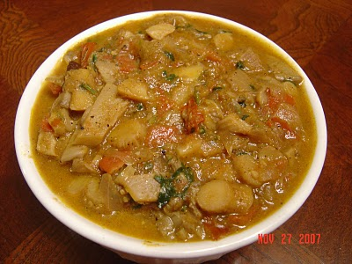
Procedure:
To clean the oyster mushrooms, just cut off the ends first. Then seperate the upper portion and the stalk. Cut the stalk and the top portion into small pieces. While adding it to the gravy, first add the stalks as it takes a few minutes extra to cook than the feathery top.
Heat oil in a kadai and fry cinnamon and cloves. Then add onion and ginger garlic paste.Saute until golden brown and soft. Then add the masala powders for fry for a minute. Now add tomatoes and cook until it becomes soft and pulpy. Make sure that it forms a paste like consistency.
Then add chopped mushrooms. First the stalks. Saute for 3 mins. Then add the top part of the mushrooms. Add 1 cup water and cook for 5 to 10 mins until you get a thick gravy. Cook till you get the desired consistency. You can also add a tsp of cornflour (just dissolve it in very little water) to make the gravy thick. I did not use it here for the sake of the event. But you can certainly do it to get a nice thick gravy.

