Oyster Mushroom Rockefeller

Yield: 24 appetizer servings

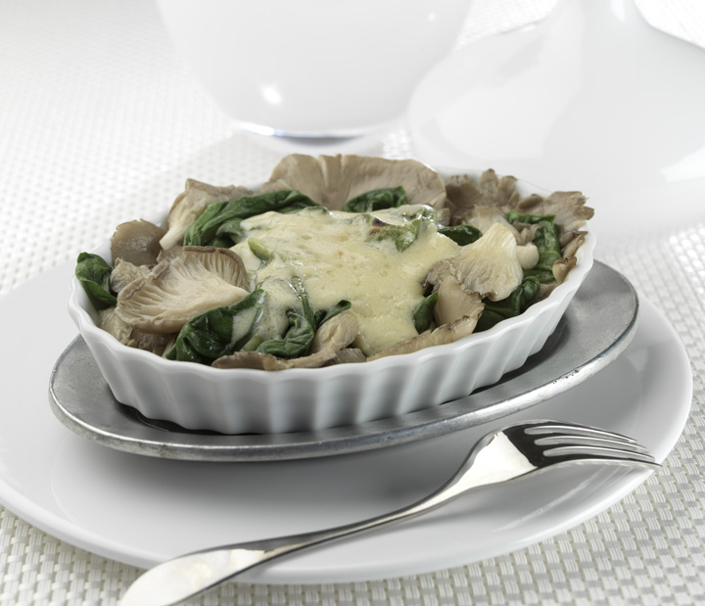
Ingredients
4 ½ pounds fresh oyster mushrooms
6 pounds fresh spinach
1 1/2 cups olive oil
2 tablespoons Dijon mustard
1 ½ cups vegan mayo
6 tablespoons Pernod (Anise liquor)
1 tablespoon salt
1 tablespoon black pepper
2 tablespoons crushed garlic
2 tablespoons sugar

Directions
Begin by removing any tough parts of the mushroom stems.

Heat a large pan with ¾ cup of the olive oil. Lightly wilt the spinach by cooking it for about 1 minute, tossing occasionally.

Whisk together the remaining ¾ cup oil, the mustard, mayo, Pernod, salt, pepper, garlic, and sugar. Refrigerate until needed. Makes about 3 cups.

For each serving, to order: Layer 3 ounces mushrooms in the bottom of a small ovenware dish, preferably a gratin or soufflé, as an individual-sized portion (or 12 ounces for 4 servings). Layer about ½ cup spinach on top for each serving. Spoon 2 tablespoons of the sauce on top of the spinach for each serving, until it is completely covered.

Bake for 15 minutes at 400 degrees, or until the sauce browns lightly. You can finish it under the broiler to get a nice brown, bubbly top; just make sure to watch it so it doesn’t burn.

Note from the chef:

Gotta love those classic throwbacks: veal oscar, beef Wellington, chicken Cordon Bleu, and of course Oysters Rockefeller. But you have to ask yourself, how did this people survive?

Here’s a fun twist on oysters Rockefeller. Oyster mushrooms alone don’t taste like seafood, and they are named after the shellfish because of their shape and pale gray color.

Even being vegan, this dish is still wonderfully decadent and indulgent. I like the effect of small, individual portions served as an appetizer. A glass of dry white wine and some oyster crackers (they don’t taste like seafood either) go perfectly with this dish.

