Super Mushroom Veggie Pasta

Makes 24 two-cup portions

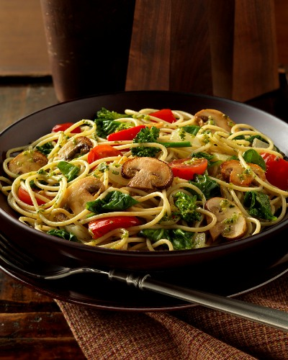

- pounds 10 ounces dried spaghetti
1/2 cup olive oil
4 pounds mushrooms, sliced
4 red bell peppers, diced
4 large onions, diced
4 cups (2 pounds) bite-size broccolini pieces
4 pints grape tomatoes
1½ pints vegetable broth
1 pint prepared pesto
4 cups (4 ounces) baby spinach leaves
Freshly grated Parmesan (for garnish)

Parboil pasta; drain and toss with a small amount of oil.

For each serving to order: Heat 1/3 cup oil in a skillet over medium-high heat, depending on size of pan, add more if needed. Add 2 to 3 ounces mushrooms, 2 tablespoons red bell pepper, and 1/3 cup onions and cook, without stirring, until mushrooms become red-brown on one side. Turn ingredients and cook until the other side is the same color. Add about 1 ounce broccolini, 2 to 3 ounces tomatoes, and 1 ounce broth, and then stir in 2 teaspoons pesto. Bring to a simmer, and then add 1/4 cup spinach and 1 cup cooked pasta.

Toss, transfer to a serving bowl, and sprinkle with fresh Parmesan.

